Module 5 UNCERTAINTY
ACTING UNDER UNCERTAINTY
Agents may need to handle uncertainty, whether due to partial observability, nondeterminism, or a combination of the two. An agent may never know what state it is in or where it will end up after a sequence of actions.

Agents often make decisions based on incomplete information
- partial observability
- nondeterministic actions
Partial solution (see previous chapters): maintain belief states
- represent the set of all possible world states the agent might be in
- generating a contingency plan handling every possible eventuality Several drawbacks:
- must consider every possible explanation for the observation (even very-unlikely ones)
=) impossibly complex belief-states
- contingent plans handling every eventuality grow arbitrarily large
- sometimes there is no plan that is guaranteed to achieve the goal

Agent’s knowledge cannot guarantee a successful outcome but can provide some degree of belief (likelihood) on it. A rational decision depends on both the relative importance of (sub)goals and the likelihood that they will be achieved. Probability theory offers a clean way to quantify likelihood.
Example
Automated taxi to Airport
- Goal: deliver a passenger to the airport on time
- Action At : leave for airport t minutes before flight: How can we be sure that A90 will succeed?
- Too many sources of uncertainty:
  - partial observability (ex: road state, other drivers’ plans, etc.)
  - uncertainty in action outcome (ex: flat tire, etc.)
  - noisy sensors (ex: unreliable traffic reports)
  - complexity of modelling and predicting traffic
With purely-logical approach it is difficult to anticipate everything that can go wrong
- risks falsehood: ―A25 will get me there on time‖ or
- leads to conclusions that are too weak for decision making: ―A25 will get me there on time if there’s no accident on the bridge , and it doesn’t rain and my tires remain intact‖
- Over-cautious choices are not rational solutions either, ex: A1440 causes staying overnight at the airport

Summarizing uncertainty
Let’s consider an example of uncertain reasoning: diagnosing a dental patient’s toothache. A medical diagnosis
- Given the symptoms (toothache) infer the cause (cavity) How to encode this relation in logic?
  - diagnostic rules:
  - Toothache → Cavity (wrong)
  - Toothache → (Cavity ∨ GumProblem ∨ Abscess ∨ ...) (too many possible causes, some very unlikely) causal rules:
  - Cavity → Toothache (wrong)
  - (Cavity 𝖠 ...) → Toothache (many possible (con)causes)
- Problems in specifying the correct logical rules: Complexity: too many possible antecedents or consequents Theoretical ignorance: no complete theory for the domain Practical ignorance: no complete knowledge of the patient
Trying to use logic to cope with a domain like medical diagnosis thus fails for three main reasons:

- Laziness: It is too much work to list the complete set of antecedents or consequents needed to ensure an exceptionless rule and too hard to use such rules.
- Theoretical ignorance: Medical science has no complete theory for the domain.
- Practical ignorance: Even if we know all the rules, we might be uncertain about a particular patient because not all the necessary tests have been or can be run.
The connection between toothaches and cavities is just not a logical consequence in either direction. This is typical of the medical domain, as well as most other judgmental domains: law, business, design, automobile repair, gardening, dating, and so on. The agent’s knowledge can at best provide only a degree of belief in the relevant sentences. Our main tool for dealing with degrees of belief is probability theory. Probability provides a way of summarizing the uncertainty that comes from our laziness and ignorance, thereby solving the qualiﬁcation problem.

- Probability allows to summarize the uncertainty on effects of laziness: failure to enumerate exceptions, qualifications, etc. ignorance: lack of relevant facts, initial conditions, etc.
- Probability can be derived from, statistical data (ex: 80% of toothache patients so far had cavities) some knowledge (ex: 80% of toothache patients has cavities) their combination.
- Probability statements are made with respect to a state of knowledge (aka evidence), not with respect to the real world
- e.g., ―The probability that the patient has a cavity, given that she has a toothache, is 0.8‖:
- P(HasCavity (patient ) | hasToothAche(patient)) = 0.8
- Probabilities of propositions change with new evidence:

- ―The probability that the patient has a cavity, given that she has a toothache and a history of gum disease, is 0.4‖:
- P(HasCavity (patient ) | hasToothAche(patient ) 𝖠 HistoryOfGum(patient )) = 0.4

Uncertainty and rational decisions
Consider again the A90 plan for getting to the airport. Suppose it gives us a 97% chance of catching ﬂight. Does this mean it is a rational choice? Not necessarily: there might be other plans, such as A180, with higher probabilities. To make such choices, an agent must ﬁrst have preferences between the different possible outcomes of the various plans. Use utility theory to represent and reason with preferences. Utility theory says that every state has a degree of usefulness, or utility, to an agent and that the agent will prefer states with higher utility.
- Ex: Suppose I believe:
- P(A25 gets me there on time |...) = 0.04
- P(A90 gets me there on time |...) = 0.70
- P(A120 gets me there on time |...) = 0.95
- P(A1440 gets me there on time |...) = 0.9999
- Which action to choose?

Preferences, as expressed by utilities, are combined with probabilities in the general theory of rationa l decisions called decision theory:
Decision theory = probability theory + utility theory .

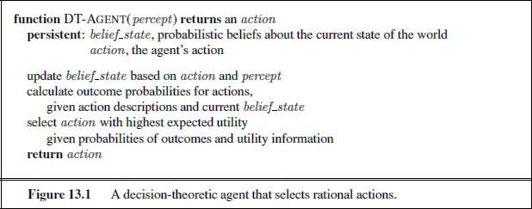
The fundamental idea of decision theory is that an agent is rational if and only if it chooses the action that yields the highest expected utility, averaged over all the possible outcomes of the action. This is called the principle of maximum expected utility (MEU).

BASIC PROBABILITY NOTATION

What probabilities are about
Like logical assertions, probabilistic assertions are about possible worlds. Whereas logical assertions say which possible worlds are strictly ruled out (all those in which the assertion is false), probabilistic assertions talk about how probable the various worlds are. In probability theory, the set of all possible worlds is called the sample space. The possible worlds are

mutually exclusive and exhaustive—two possible worlds cannot both be the case, and one possible world must be the case. For example, if we are about to roll two (distinguishable) dice, there are 36 possible worlds to consider: (1,1), (1,2), ..., (6,6). The Greek letter Ω (uppercase omega) is used to refer to the sample space, and ω (lowercase omega) refers to elements of the space, that is, particular possible worlds.
A fully speciﬁed probability model associates a numerical probability P (ω) with each possible world.1 The basic axioms of probability theory say that every possible world has a probability between 0 and 1 and that the total probability of the set of possible worlds is 1:

- Sample space Ω: the set of all possible worlds
- ω ∈ Ω is a possible world (aka sample point or atomic event) ex: the dice roll (1,4)
- the possible worlds are mutually exclusive and exhaustive. ex: the 36 possible outcomes of rolling two dice: (1,1), (1,2), ...
- A probability model (aka probability space) is a sample space with an assignment P(ω) for every ω ∈ Ω s.t.
  - 0 ≤ P(ω) ≤ 1, for every ω ∈ Ω Σω∈ΩP(ω) = 1
- Ex: 1-die roll: P(1) = P(2) = P(3) = P(4) = P(5) = P(6) = 1/6
- An Event A is any subset of Ω, s.t. P(A) = Σω∈AP(ω)
  - events can be described by propositions in some formal language ex: P(Total
= 11) = P(5, 6) + P(6, 5) = 1/36 + 1/36 = 1/18
  - ex: P(doubles) = P(1, 1) + P(2, 2) + ... + P(6, 6) = 6/36 = 1/6

Probabilities such as P (Total = 11) and P (doubles) are called unconditional or prior probabilities (and sometimes just ―priors‖ for short); they refer to degrees of belief in propositions in the absence of any other information.

Unconditional or prior probabilities refer to degrees of belief in propositions in the absence of any other information (evidence)
ex: P(cavity ) = 0.2, P(Total = 11) = 1/18, P(double) = 1/6

Conditional or posterior probabilities refer to degrees of belief in proposition a given some evidence b: P(a|b)
- evidence: information already revealed
- ex: P(cavity |toothache) = 0.6: p. of a cavity given a toothache (assuming no other information is provided!)
- ex: P(Total = 11|die1 = 5) = 1/6: p. of total 11 given first die is 5
- restricts the set of possible worlds to those where the first die is 5
Note: P(a|... 𝖠 a) = 1, P(a|... 𝖠 ¬a) = 0. ex: P(cavity |toothache 𝖠 cavity ) = 1, P(cavity
|toothache 𝖠 ¬cavity ) = 0

- Less specific belief still valid after more evidence arrives. ex: P(cavity ) = 0.2 holds even if P(cavity |toothache) = 0.6

- New evidence may be irrelevant, allowing for simplification. ex: P(cavity |toothache, 49ersWin) = P(cavity |toothache) = 0.8
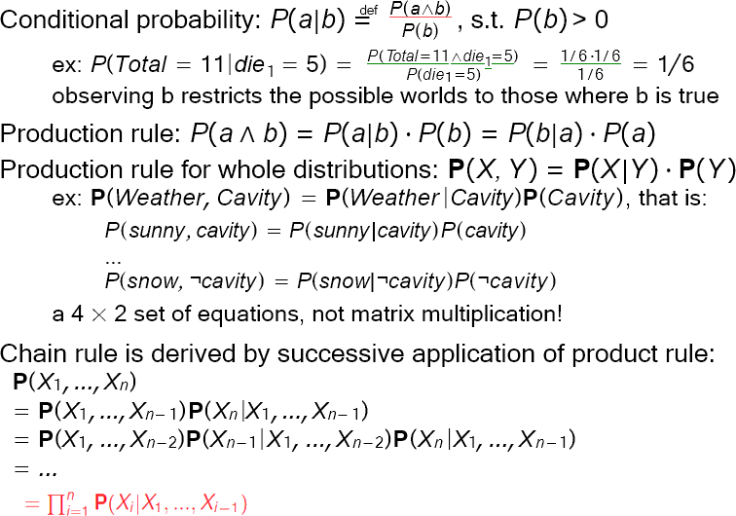

The language of propositions in probability assertions
- Factored representation of possible worlds: sets of ⟨variable, value⟩ pairs Variables in probability theory: Random variables
- domain: the set of possible values a variable can take on
- ex: Die: {1, 2, 3, 4, 5, 6}, Weather: {sunny, rain, cloudy, snow }, Odd: {true, false}
- A random variable can be seen as a function from sample points to the domain: ex:
Die(ω), Weather (ω),... (―(ω)‖ typically omitted)
- Probability Distribution gives the probabilities of all the possible values of a random variable
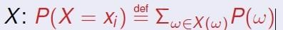
ex: P(Odd = true) = P(1) + P(3) + P(5) = 1/6 + 1/6 + 1/6 = 1/2

―The probability that the patient has a cavity, given that she is a teenager with no toothache, is 0.1‖ as follows:
P (cavity |¬toothache 𝖠 teen)=0.1 .

Probability Distribution gives the probabilities of all the possible values of a random variable
ex: P (Weather = sunny)=0.6 P (Weather = rain )=0.1
P (Weather = cloudy)=0.29 P (Weather = snow)=0.01 ,
but as an abbreviation we will allow P(Weather)= 0.6, 0.1, 0.29, 0.01

where the bold P indicates that the result is a vector of numbers, and where we assume a pre deﬁned ordering sunny, rain , cloudy , snow on the domain of Weather. We say that the P statement deﬁnes a probability distribution for the random variable Weather.TheP notation is also used for conditional distributions: P(X | Y ) gives the values of P (X = xi | Y = yj) for each possible i, j pair.

For continuous variables, it is not possible to write out the entire distribution as a vector, because there are inﬁnitely many values. Instead, we can deﬁne the probability that a random variable takes on some value x as a parameterized function of x. For example, the sentence P (NoonTemp = x)=Uniform[18C,26C](x) expresses the belief that the temperature at noon is distributed uniformly between 18 and 26 degrees Celsius. We call this a probability density function.

P(Weather , Cavity) denotes the probabilities of all combinations of the values of Weather and Cavity. This is a 4 × 2 table of probabilities called the joint probability distribution of Weather and Cavity.
For example, the product rules for all possible values of Weather and Cavity can be written as a single equation:
P(Weather , Cavity)=P(Weather | Cavity)P(Cavity) ,

Probability axioms and their reasonableness
The basic axioms of probability imply certain relationships among the degrees of belief that can be accorded to logically related propositions. We think a proposition a as the event A (set of sample points) where the proposition is true
- Odd is a propositional random variable of range {true, false}
- notation: a ⇐⇒ ―A = true′′
- Given Boolean random variables A and B:
- a: set of sample points where A(ω) = true
- ¬a: set of sample points where A(ω) = false
- a 𝖠 b: set of sample points where A(ω) = true, B(ω) = true
- with Boolean random variables, sample points are PL models Proposition: disjunction of the sample points in which it is true
ex: (a ∨ b) ≡ (¬a 𝖠 b) ∨ (a 𝖠 ¬b) ∨ (a 𝖠 b) P(a ∨ b) = P(¬a 𝖠 b) + P(a 𝖠 ¬b) + P(a 𝖠 b)
- Some derived facts:
P(¬a) = 1 − P(a)
We can also derive the well known formula for the probability of a disjunction, sometimes called the inclusion–exclusion principle:
P(a ∨ b) = P(a) + P(b) − P(a 𝖠 b)

INFERENCE USING FULL JOINT DISTRIBUTIONS
For probabilistic inference—that is, the computation of posterior probabilities for query propositions given observed evidence. We use the full joint distribution as the ―knowledge base‖ from which answers to all questions may be derived.
Example: a domain consisting of just the three Boolean variables Toothache, Cavity, and Catch The full joint distribution is a 2×2×2 table as shown in Figure 13.3.
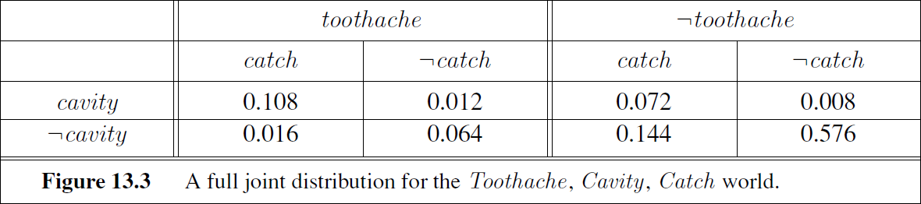
Notice that the probabilities in the joint distribution sum to 1, as required by the axioms of probability.
For example, there are six possible worlds in which cavity ∨ toothache holds:
P(cavity ∨ toothache) = 0.108 + 0.012 + 0.072 + 0.008 + 0.016 + 0.064 = 0.28.
Adding the entries in the first row gives the unconditional or marginal probability of cavity: P(cavity) = 0.108 + 0.012 + 0.072 + 0.008 = 0.2
This process is called marginalization, or summing out—because we sum up the probabilities for each possible value of the other variables, thereby taking them out of the equation.

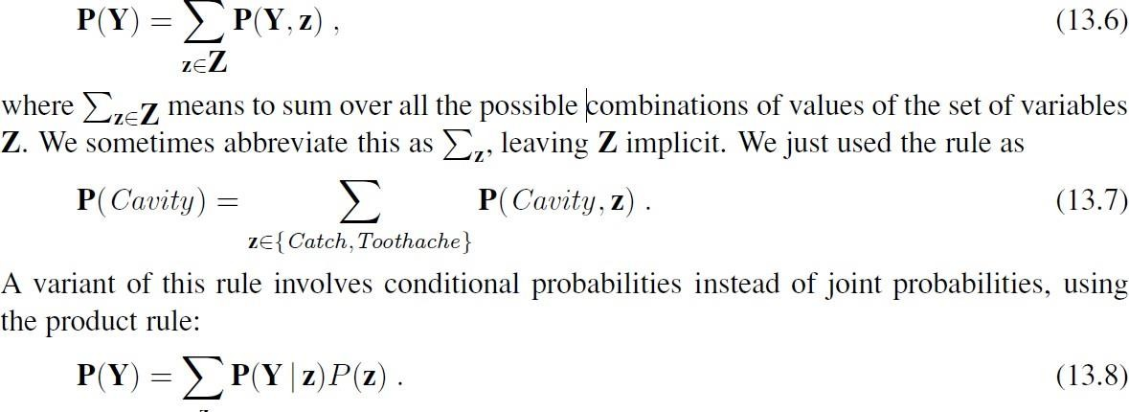
We can write the following general marginalization rule for any sets of variables Y and Z:
This rule is called conditioning. Marginalization and conditioning turn out to be useful rules for all kinds of derivations involving probability expressions.

For example, we can compute the probability of a cavity, given evidence of a toothache, as follows:

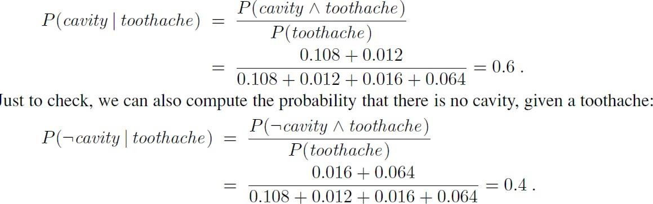
The two values sum to 1.0, as they should. Notice that in these two calculations the term 1/P(toothache ) remains constant, no matter which value of Cavity we calculate. In fact, it can be viewed as a normalization constant for the distribution P(Cavity | toothache), ensuring that it adds up to 1. we can write the two preceding equations in one:
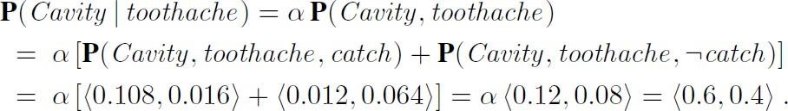

A general inference procedure:
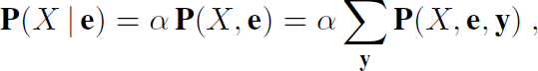
The query is P(X | e) and can be evaluated as
where the summation is over all possible ys (i.e., all possible combinations of values of the unobserved variables Y). Notice that together the variables X, E, and Y constitute the complete set of variables for the domain, so P(X, e, y) is simply a subset of probabilities from the full joint distribution.

INDEPENDENCE
Expand the full joint distribution in Figure 13.3 by adding a fourth variable, Weather. The full joint distribution then becomes P(Toothache , Catch, Cavity, Weather ), which has 2 × 2 × 2 × 4 = 32 entries. It contains four ―editions‖ of the table shown in Figure 13.3, one for each kind of weather. What relationship do these editions have to each other and to the original three- variable table? For example, how are P (toothache , catch , cavity , cloudy) and P (toothache , catch , cavity ) related? We can use the product rule:

P (toothache , catch , cavity , cloudy) = P (cloudy | toothache , catch , cavity )P (toothache , catch , cavity )
the weather does not inﬂuence the dental variables. Therefore, the following assertion seems reasonable:

P (cloudy | toothache , catch , cavity )=P (cloudy) .
From this, we can deduce

P (toothache , catch , cavity , cloudy)=P (cloudy)P (toothache , catch , cavity ) .

we can write the general equation

P(Toothache, Catch, Cavity, Weather )=P(Toothache , Catch, Cavity)P(Weather ) .

The 32-element table for four variables can be constructed from one 8-element table and one 4-element table. This decomposition is illustrated schematically in Figure below.
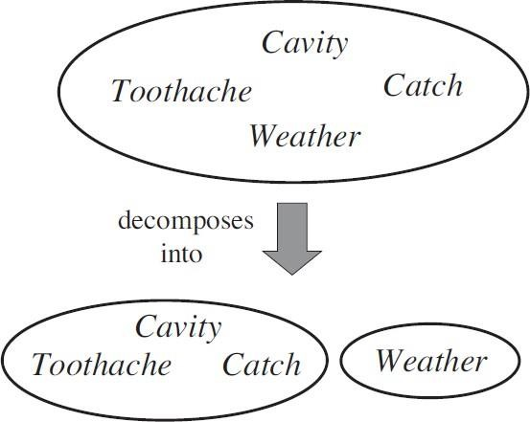
The weather is independent of one’s dental problems. Independence between propositions a and b can be written as
Independence between variables X and Y can be written as follows

BAYES’RULE AND ITS USE

Deﬁned the product rule. It can actually be written in two forms
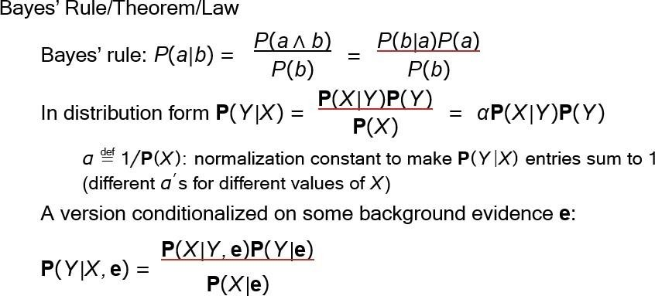

Applying Bayes’ rule: The simple case

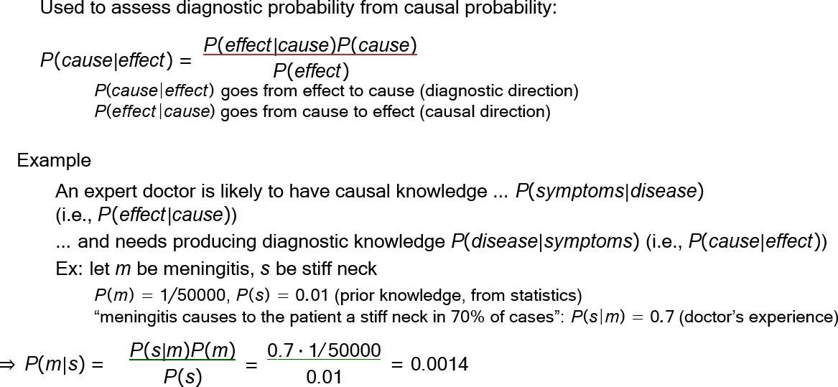

Using Bayes’ rule: Combining evidence

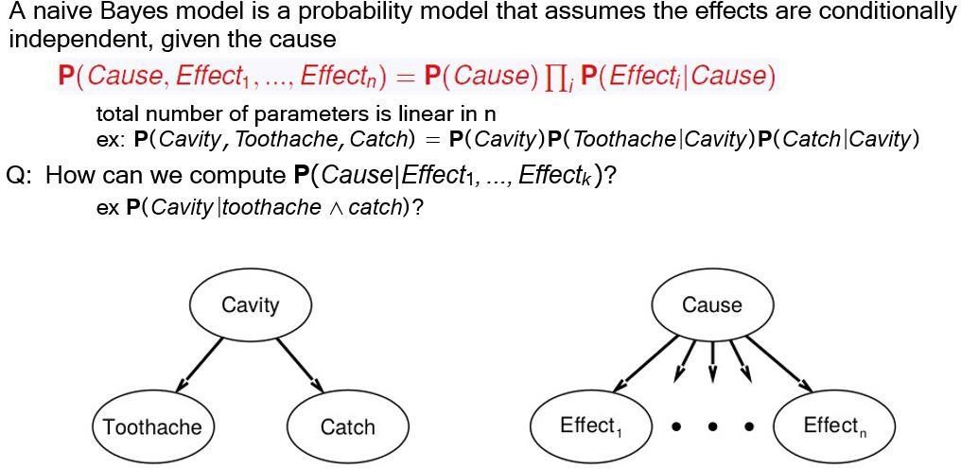

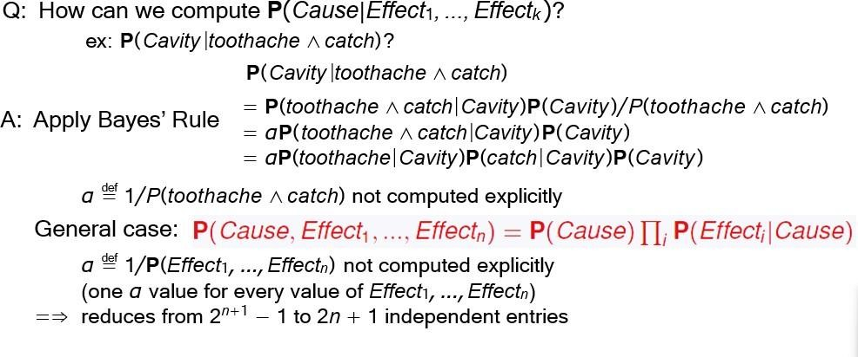

THE WUMPUS WORLD REVISITED
To calculate the probability that each of the three squares contains a pit. (For this example we ignore the wumpus and the gold.) The relevant properties of the wumpus world are that (1) a pit causes breezes in all neighboring squares, and (2) each square other than [1,1] contains a pit with probability 0.2. The ﬁrst step is to identify the set of random variables we need:
to specify the full joint distribution, P(P1,1,...,P4,4,B1,1,B1,2,B2,1). Applying the product rule, we have

P(P1,1,...,P4,4,B1,1,B1,2,B2,1) = P(B1,1,B1,2,B2,1 | P1,1,...,P4,4)P(P1,1,...,P4,4)

This decomposition makes it easy to see what the joint probability values should be. The first term is the conditional probability distribution of a breeze configuration, given a pit configuration; its values are 1 if the breezes are adjacent to the pits and 0 otherwise. The second term is the prior probability of a pit configuration. Each square contains a pit with probability 0.2, independently of the other squares; hence,
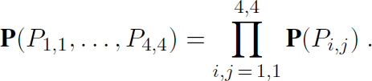

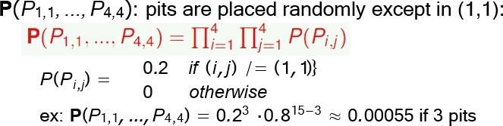

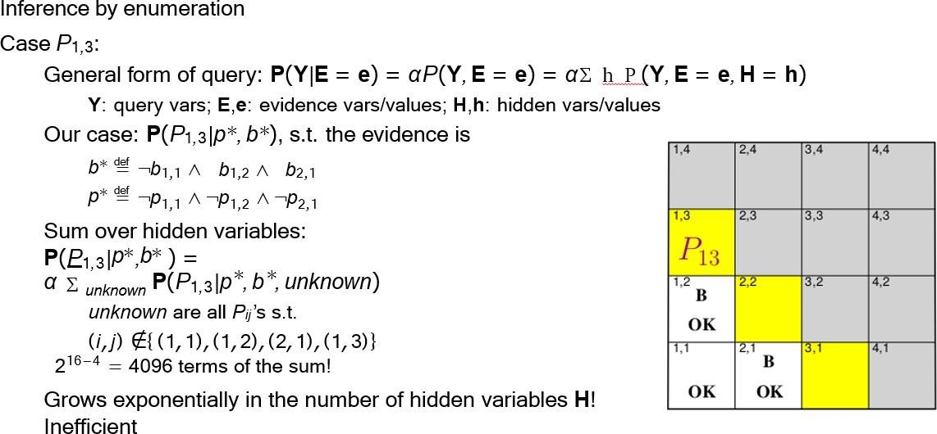

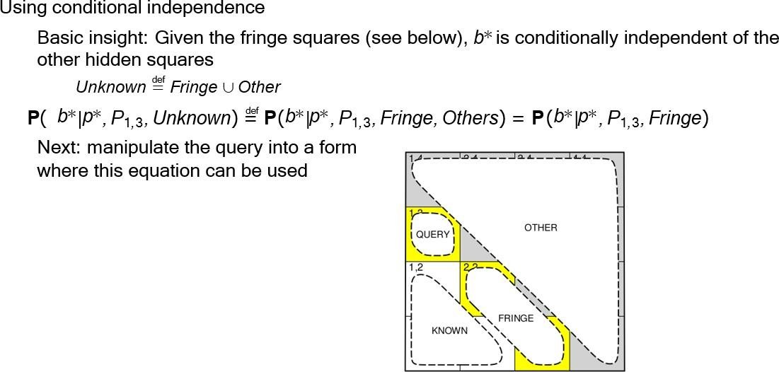

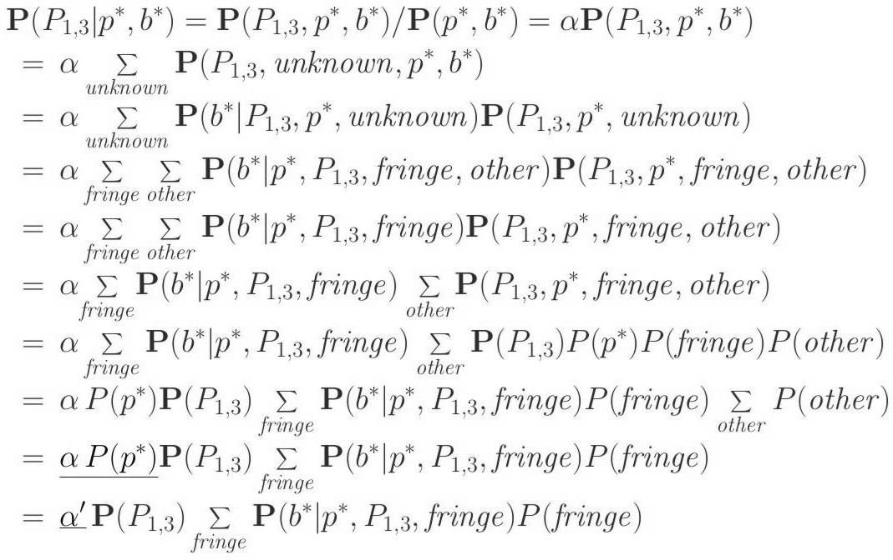
P(p∗) is scalar, so make it part of the normalization constant

